 **Hong Kong Institute of Vocational Education**

**ITP4506 Human Computer Interaction and GUI Programming**

**E-commerce Website**

|  |  |  |  |
| --- | --- | --- | --- |
| **Student ID** | **Name** | **Contribution** | **Signature** |
| 160450066 | LamKitYu | 50% |  |
| 160548082 | YauTsunSing | 50% |  |

Table of Contents

1. Background 1

2. User Analysis 2

2.1. User characteristics 2

2.1.1. Learning style 2

2.1.2. Tool preferences 2

2.1.3. Physical differences 3

2.1.4. Cultural differences 3

2.1.5. Knowledge of job 3

2.1.6. Application familiarity 3

2.1.7. Primary and secondary users 3

2.2. Techniques for observing and listening to users 4

2.2.1. Think aloud 4

2.2.2. Talk right after 4

2.2.3. Role-playing 4

2.2.4. Cueing recall with videotape 4

2.2.5. Focus groups 4

2.2.6. Mailed/Online surveys 4

2.3. Environment Analysis 5

2.4. Recruiting Users 5

2.5. Task Analysis (HTA) 5

3. Web Concept 6

3.1. User Interface design 6

3.1.1. Home Page 6

3.1.2. Hotel page 7

3.1.3. Flight page 8

3.1.4. Register/Login Page 9

3.1.5. Shopping cart page 10

3.1.6. Payment Page 11

3.1.7. Profile Page 12

4.1. Function 13

4.1.1. Register/Login 13

# Background

The Happy Travel Ltd is a medium-sized travel agent. This company want to build a website for the tertiary student in Hong Kong. First, the website user interface should be user-friendly. Also, the website should be provide the search function for user searching the items. Moreover, it should be offer the hotel and flight function for user choosing. However, the website should be provide a shopping cart, let the user add the item to the cart. Furthermore, it would be having a membership system for user since they need to login to get a discount.

# User Analysis

## User characteristics

### Learning style

The website is target on the student so the user have a high learning skills to use the website. The users’ habits of learning are Read-then-do. The student will go to website first, they will see what is the information will show on the website. After they read the website, they can easy to use it. The user enter the website, they will see the photo 1. They enter this website because the want to search or buy the flight ticket or book the hotel. They can click the item on the top menu. It design can let the user easily to read the first page content.

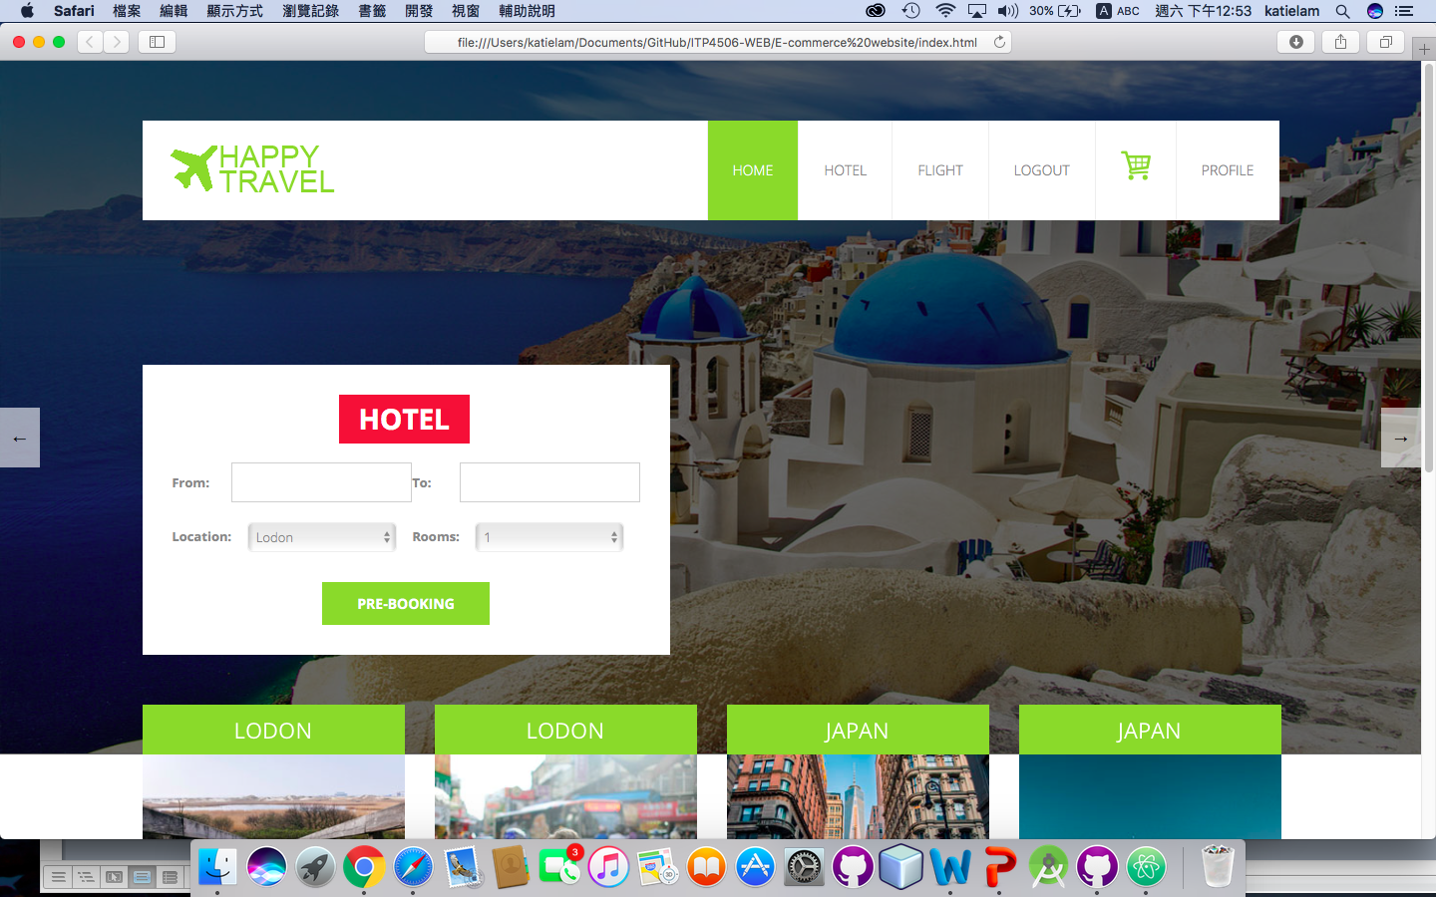(Photo 1)

### Tool preferences

The website will provide the search engines, menu and slide show. For the search engines, the website is used the flexible box to include the search item. The user can select the date from the date picker, location, number of room and number of people are also is drop-down menu. When they click the input box, it will pop up the drop down menu or date picker. It is no need to enter the information. The user chooses it only. For the menu, the website is clearly to set the name of the menu. Also, the shopping cart uses a cart logo to present it. Using photo can easy to show the meaning. For the slideshow, the slideshow both side have a button of changing. That can show to user the slide have another information.

### Physical differences

Abilities among different people may be different but this website is target on the tertiary student. So the age is around 18-30. Also, the target group has men and female. However, Considering of the vision limitations such as color blindness so the website would be set the color of green, white and grey of main color. The font sizes are not too large and too small. The title set to 18px. The content may set 14-16px.

|  |  |
| --- | --- |
| Font sizes (Title) | 18px |
| Font sizes (content) | 14-16px |
| Main color of website | Green, white and grey |

### 2.1.4. Cultural differences

The target customer is the tertiary student so they have a higher education level. Also, the reading level is also higher. For the website using specialized vocabularies, the user also can understand the meaning and they no need to check the dictionary. The website language could use English.

### Knowledge of job

For the travel agent is using specialized vocabularies. For example, customer service, booking, flight, hotel, deals, available, main amenities etc.

### Application familiarity

For the novice, they need to a guideline to follow the step-by-step using the website.

About the Expert, they no need a guideline to follow the step-by-step using the website. They can learn

### Primary and secondary users

|  |  |
| --- | --- |
| Primary User | Secondary User |
| Hotel reservation clerk | Customer who called the support line |
| Flight reservation clerk | Tertiary student |
| Travel agent |  |

## 2.2. Techniques for observing and listening to users

## 2.2.1. Think aloud

Ask the user what they want in this website. Doing the website before, we should do a search and questionnaire to collect the requirements. Listening to users think and plan, it will be able to examine their expectations for the website. Also, Listening to users as they work could provide enormous amount of useful information about develop the website.

### 2.2.2. Talk right after

After collected the information or feedback, we should discuss which comment or suggest it quite good. After the decision, we should talk about the work is it effective or easy to do.

### 2.2.3. Role-playing

Flight reservation clerk and hotel reservation clerk are no way to observe. So we need to play the role of these users in that situation.

### 2.2.4. Cueing recall with videotape

We should mark the requirements after the decision that can remind us to the website what should we have. The records should be having the user explain what was going on.

### 2.2.5. Focus groups

Regarding some students are less willing to express opinions in the public, we can do an online observation. About a group of people are asked about their perceptions, opinions, beliefs, and attitudes towards a product or service, we can search another travel agent website for our reference. It can collect some ideas for the new website for student.

### 2.2.6. Mailed/Online surveys

We would like to do an online survey because this is inexpensive. Also, in this century, the student also uses the computer and mobile. They are willing to do it in online.

## 2.3. Environment Analysis

The user also use the website at home. So we need to set the color is not too bright or too dark. We should provide a comfortable interface for user. Also, the website has enough areas to show the information since the user’s computer screen is big. We can offer a scroll to move the web page.

## 2.4. Recruiting Users

In the website, post notice or ask a professor to announce provide incentives, if they are do an online survey, they can get the prize. It is a good way to get the feedback when we are want to improve the website.

## 2.5. Task Analysis (HTA)

0. In order to book a hotel from the happy travel Ltd website

1. Go to the website

2. Find the required hotel

2.1 access website catalogue

2.2 access the search screen

2.3 enter search criteria

2.4 identify required hotel

2.5 note location

3. Add to shopping cart

4. Go to shopping cart to check out

5. Fill in all the information to pay

0. In order to buy a flight ticket from the happy travel Ltd website

1. Go to the website

2. Find the required flight ticket

2.1 access website catalogue

2.2 access the search screen

2.3 enter search criteria

2.4 identify required flight ticket

2.5 note location

3. Add to shopping cart

4. Go to shopping cart to check out

5. Fill in all the information to pay

### 2.5.1. Use Case

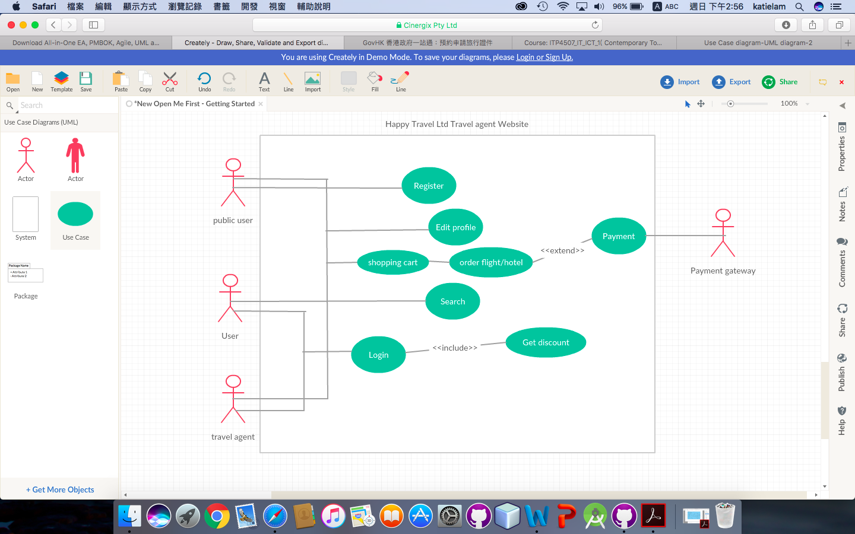

# Web Concept

## 3.1. User Interface design

|  |  |
| --- | --- |
| Design Principles | Description |
| Mental Model | Arrow logo: move left or right |
| Affordance | Search function, move the slide (left or right) |
| Content Organization | Header: menu and search function (hotel or flight)  Body: package of flight and hotel suggestion  Footer: company logo |
| Visual Organization | If click the menu, they body will change the content only.  Also, which menu is clicked, it will be change to green color. |
| Navigation | The company logo will connect to home page.  All menu will connect to their own page. |

### 3.1.1. Home Page



header

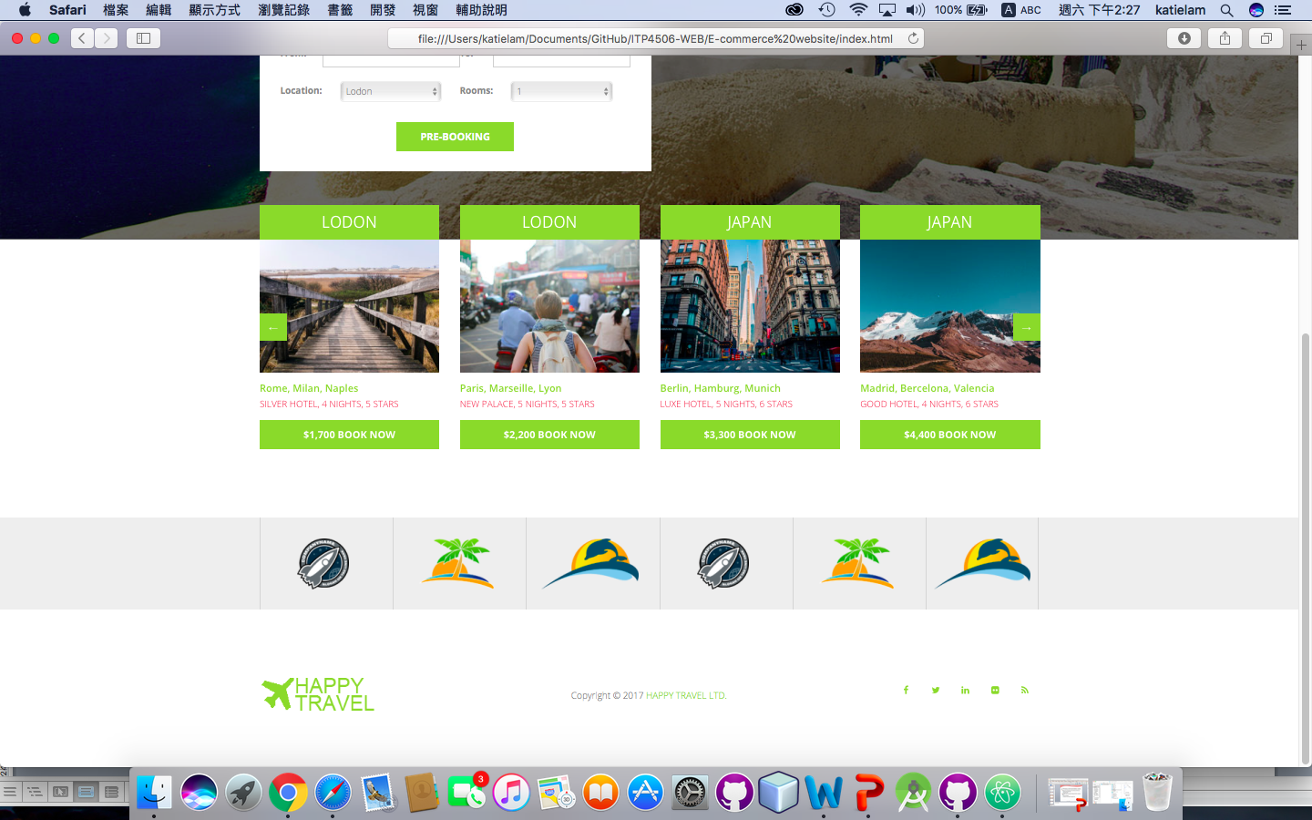

body

footer

### 3.1.2. Hotel page

|  |  |
| --- | --- |
| Design Principles | Description |
| Mental Model | scroll: move up and down |
| Affordance | Search hotel function, drop down list, input box and button |
| Content Organization | Header: menu  Body: search hotel function and hotel list view  Footer: company logo |
| Visual Organization | If click the menu, they body will change the content only.  Also, which menu is clicked, it will be change to green color.  Click the “Book a hotel”, it will change to “cancel the hotel” |
| Navigation | The company logo will connect to home page.  All menus will connect to their own page. |

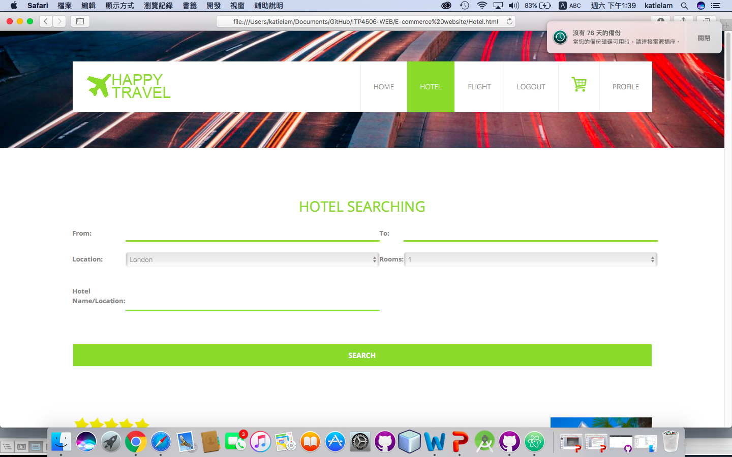

header

body

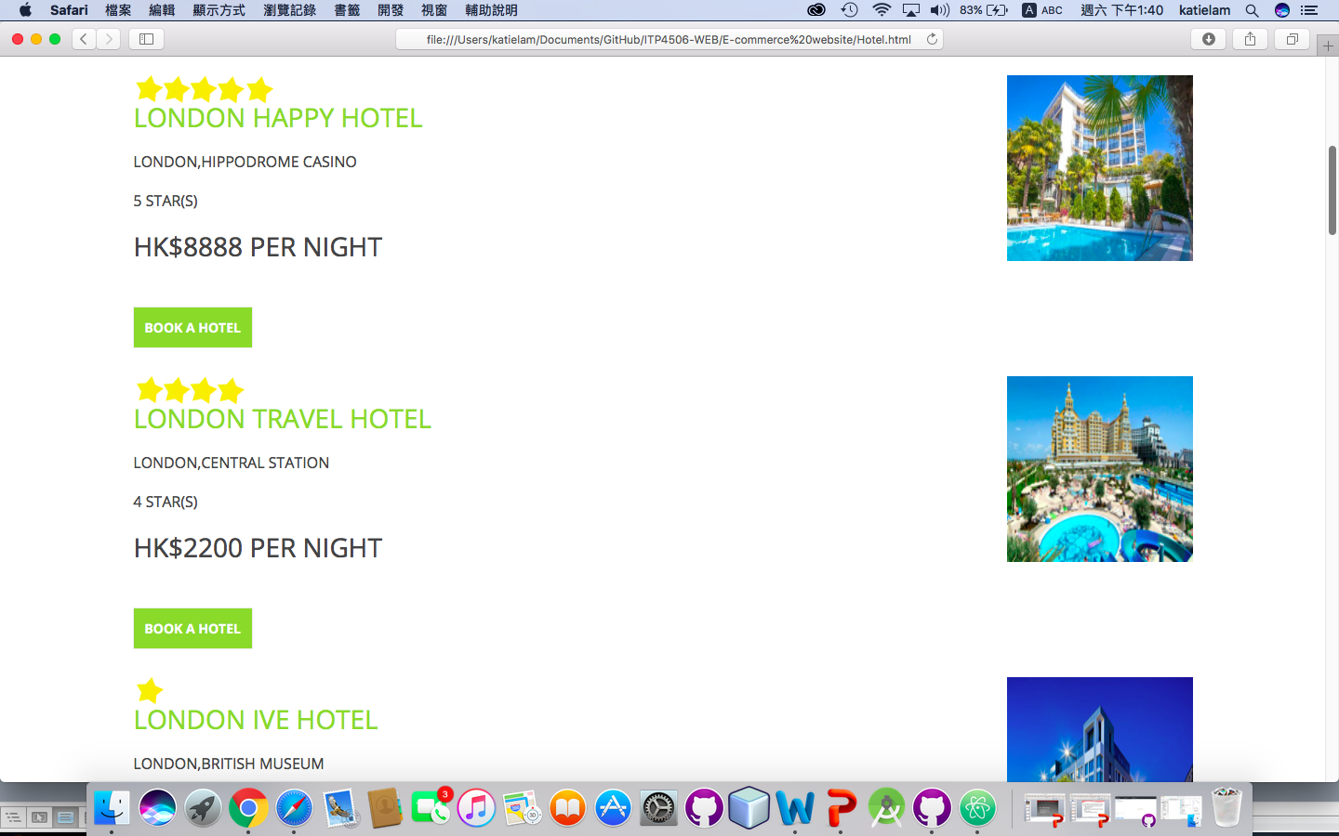

|  |  |
| --- | --- |
| Design Principles | Description |
| Mental Model | scroll: move up and down |
| Affordance | Search flight function (input box and button) |
| Content Organization | Header: menu  Body: search flight function and flight list view  Footer: company logo |
| Visual Organization | If click the menu, they body will change the content only.  Also, which menu is clicked, it will be change to green color.  Click the “Book a ticket”, it will change to “cancel the ticket” |
| Navigation | The company logo will connect to home page.  All menus will connect to their own page. |

### 3.1.3. Flight page

### Macintosh HD:Users:katielam:Desktop:螢幕快照 2017-10-14 下午1.48.25.png

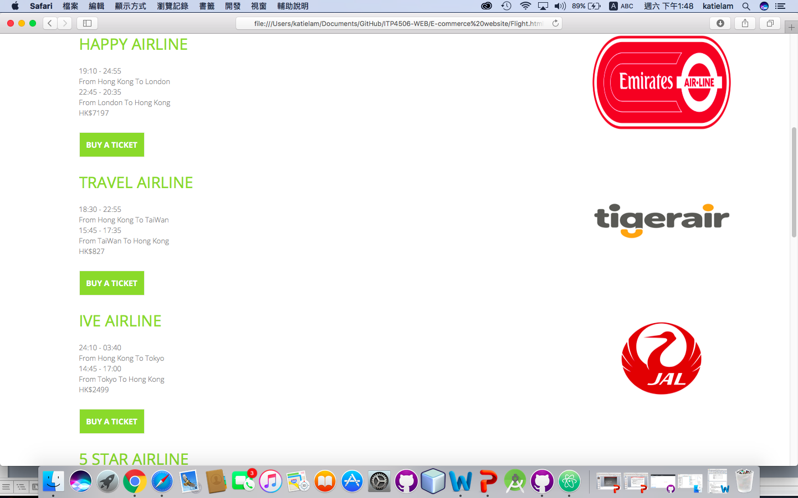

Body

|  |  |
| --- | --- |
| Design Principles | Description |
| Mental Model | scroll: move up and down |
| Affordance | Register form and login form (input box and button) |
| Content Organization | Header: menu  Body: Register form and login form  Footer: company logo |
| Visual Organization | After the user fill in all the blank, click the “register”/”login”  They will also pop up the modal box/alert window. |
| Navigation | The company logo will connect to home page.  All menus will connect to their own page. |

### 3.1.4. Register/Login Page

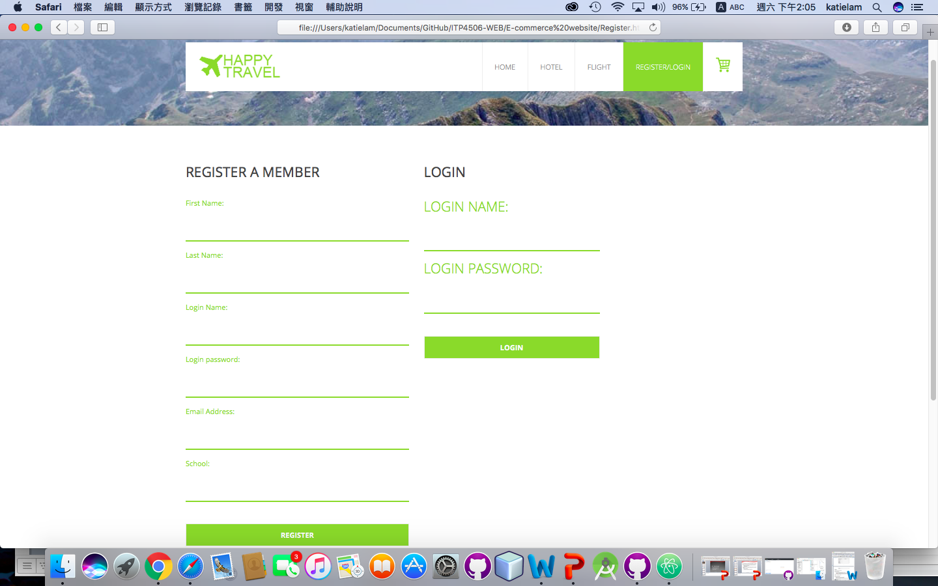

Body

Header

### 3.1.5. Shopping cart page

|  |  |
| --- | --- |
| Design Principles | Description |
| Mental Model | Scroll: move up and down |
| Affordance | “Payment” button |
| Content Organization | Header: menu  Body: list view of shopping cart  Footer: company logo |
| Visual Organization | Click the “Payment” button, will go to payment page |
| Navigation | The company logo will connect to home page.  All menus will connect to their own page. |

### Macintosh HD:Users:katielam:Desktop:螢幕快照 2017-10-14 下午11.47.54.pngMacintosh HD:Users:katielam:Desktop:螢幕快照 2017-10-14 下午11.48.00.png

### 3.1.6. Payment Page

|  |  |
| --- | --- |
| Design Principles | Description |
| Mental Model | Scroll: move up and down |
| Affordance | “Login” button, “Pay now” button, “Add your personal information” button, input box |
| Content Organization | Header: menu  Body: Payment form, “Login” button, “Pay now” button, “Add your personal information” button  Footer: company logo |
| Visual Organization | Click the “Pay now” button, will pop up the modal box.  Click the “Add your personal information” button, will add the personal information to the input box.  Click the “login” button, will go to the login page. |
| Navigation | The company logo will connect to home page.  All menus will connect to their own page. |

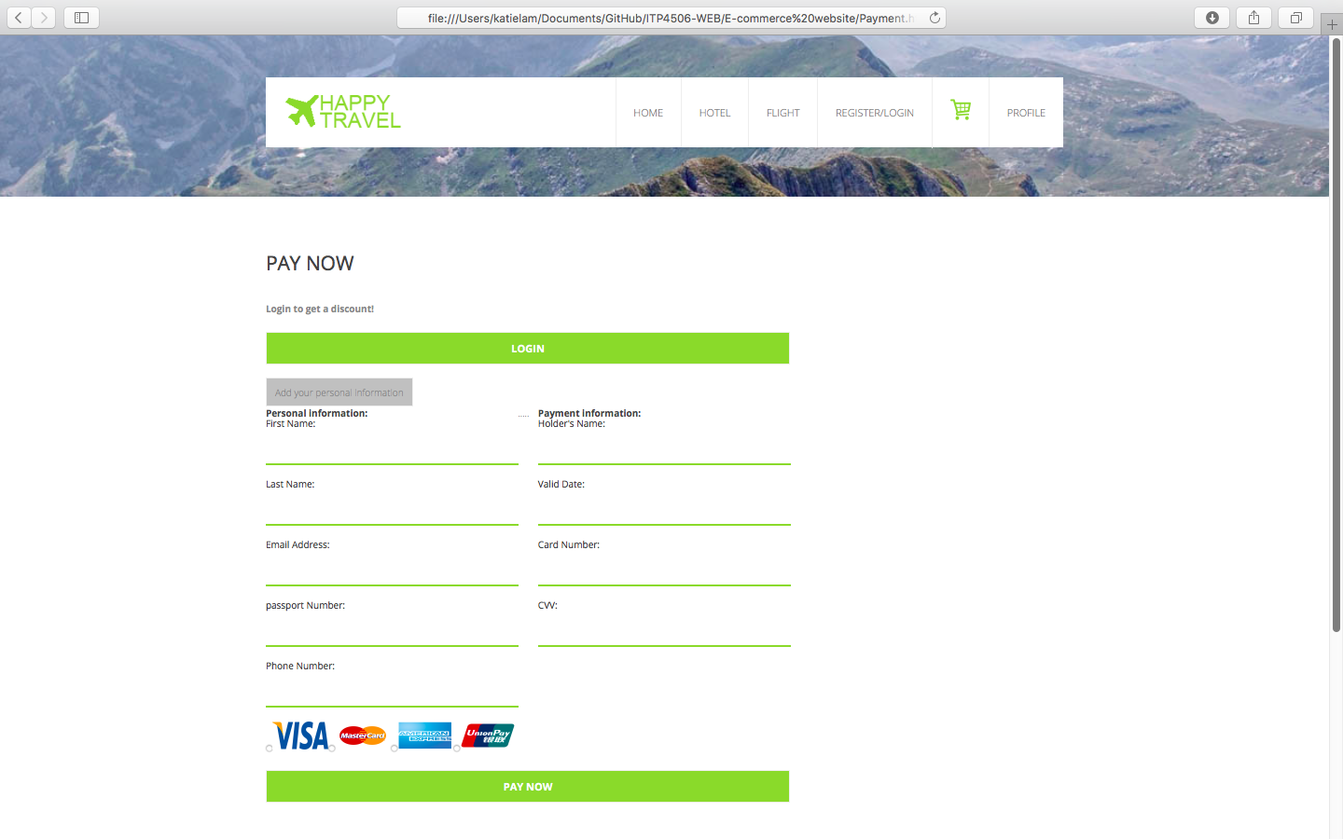

Body

Header

### 3.1.7. Profile Page

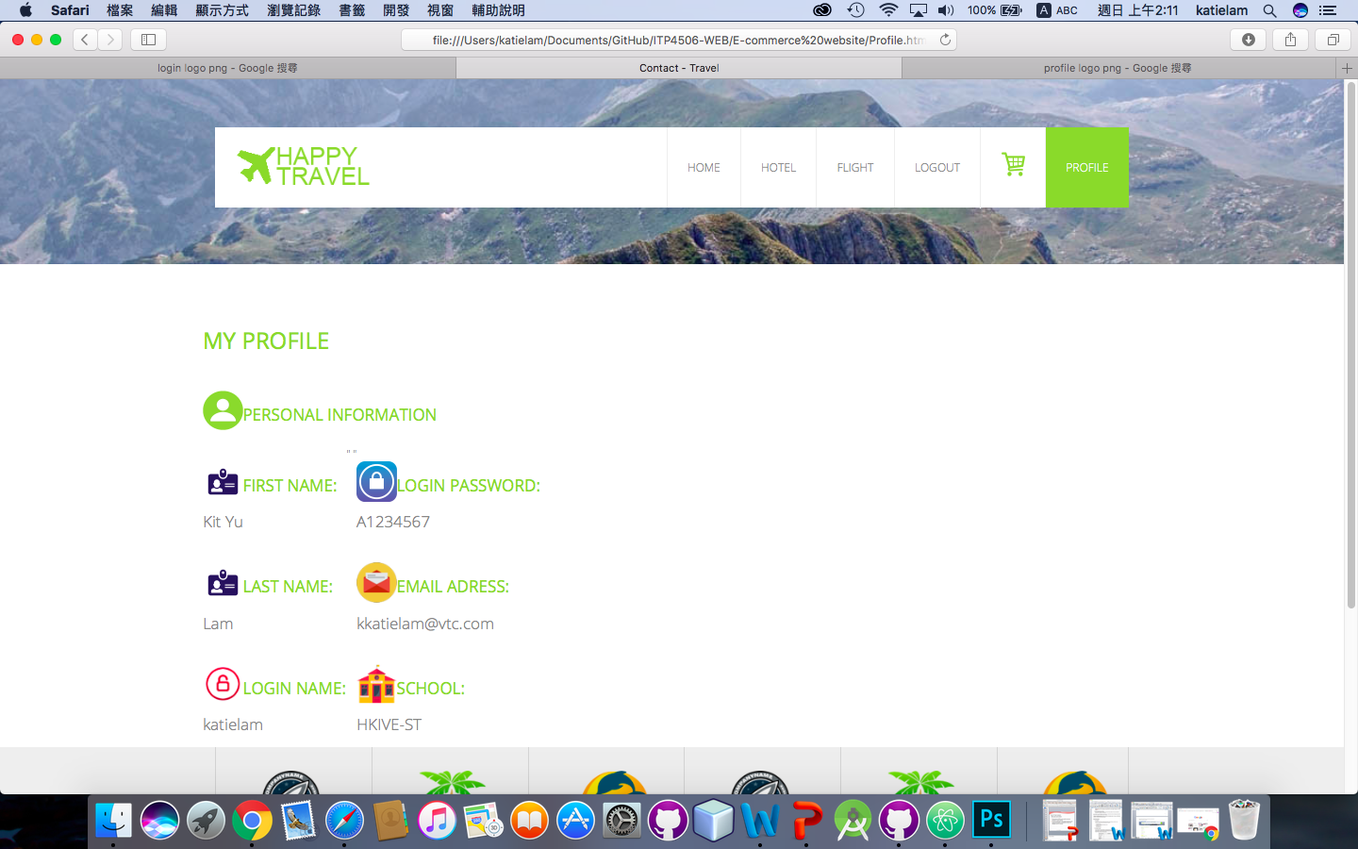

Header

Body

|  |  |
| --- | --- |
| Design Principles | Description |
| Mental Model | Scroll: move up and down |
| Affordance | Input box |
| Content Organization | Header: menu  Body: personal information  Footer: company logo |
| Visual Organization | You can see your personal information here. |
| Navigation | The company logo will connect to home page.  All menus will connect to their own page. |

# 4.1. Function

## 4.1.1. Register/Login

1. Fill in all input box.

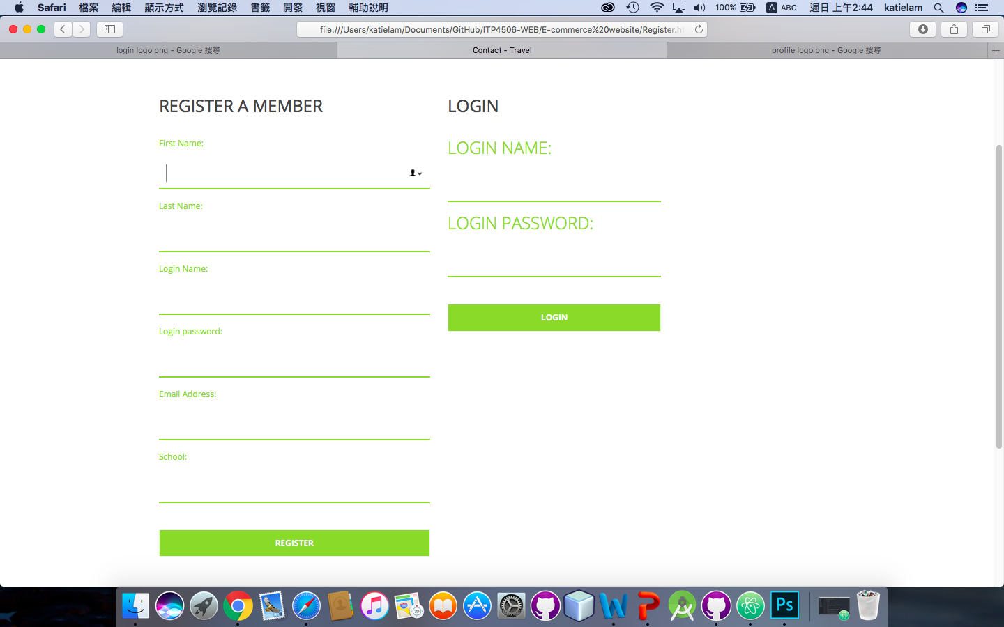

2. Click “Register” button



3.Pop-up the Modal box

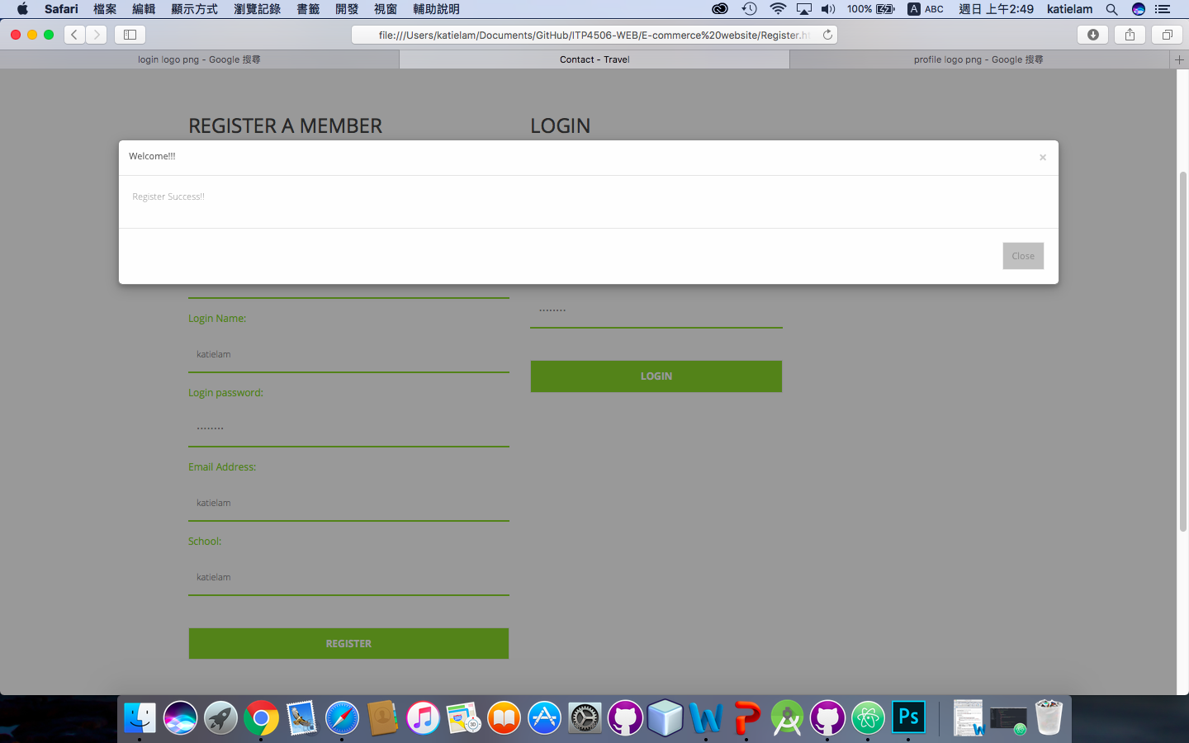

4. Input the login name and login password.

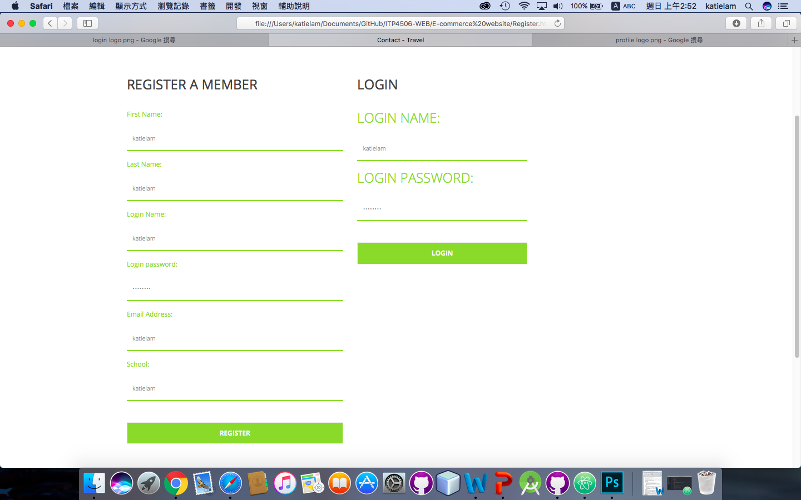

5. Click “Login” button

